**Lab 4 Report**

*Diagram*

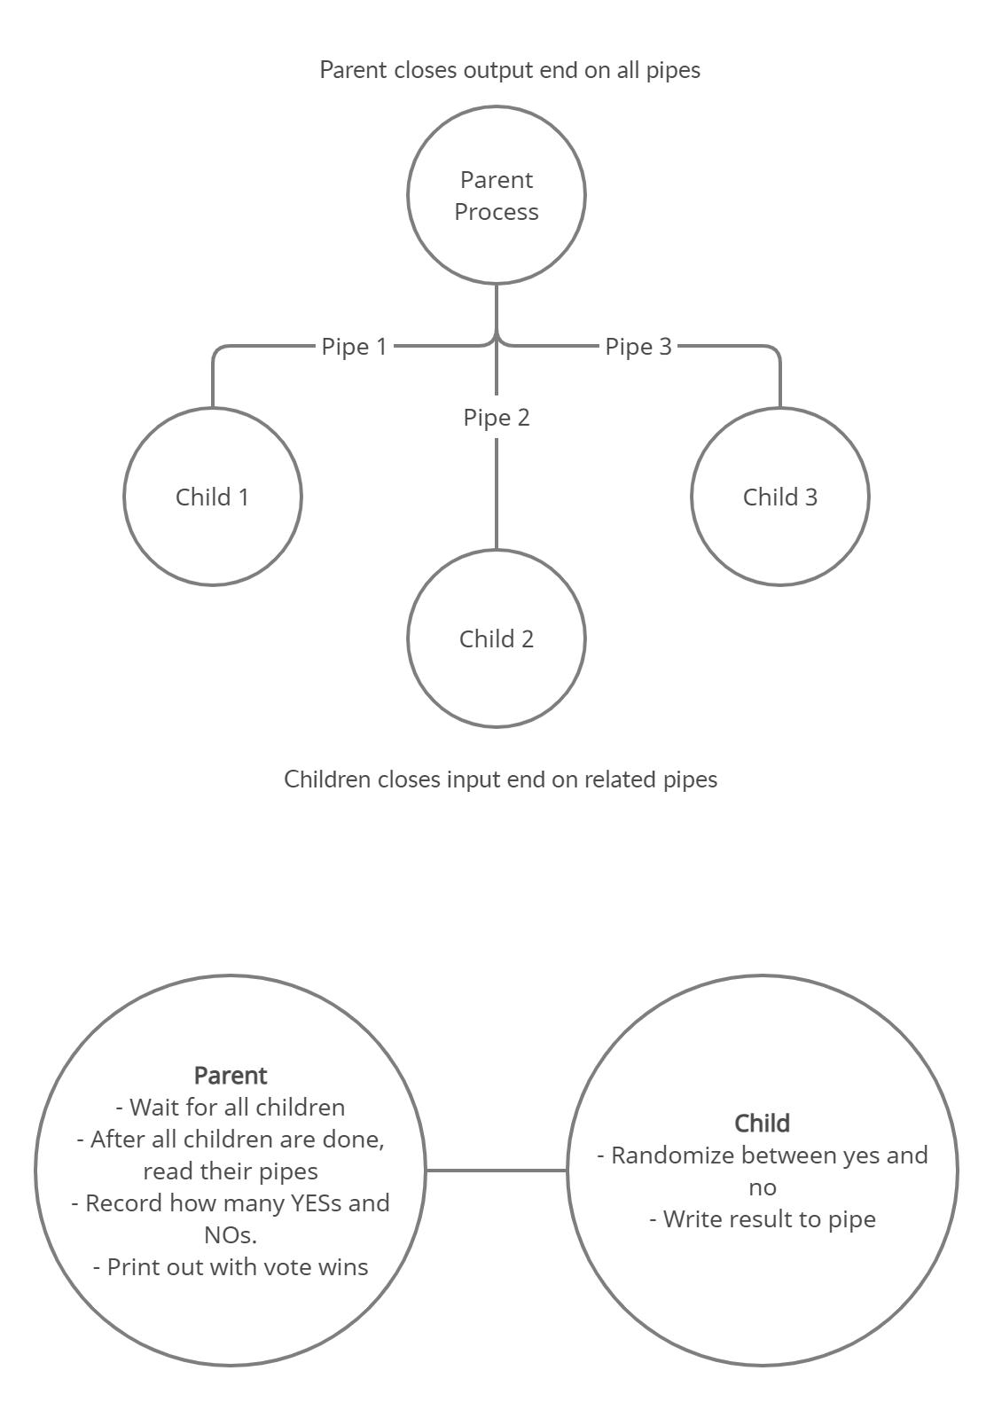

*Compiling my program*

I used the following command: gcc -o vote vote.c

*Running the program*

I run it using ./vote

*Screenshots*

